

**The DIAMOND Foundation, Inc.**

# Kappa Alpha Psi Fraternity, Inc., P.O. Box 1394, Somerset, New Jersey 08875-1394

### www.diamondfoundationinc.org

### Established in 2003

# 2020 Scholarship Application

Dear Student:

**The DIAMOND Foundation, Inc.** was founded on June 24, 2003 as a 501(c)(3) non-profit tax-exempt philanthropic foundation of the New Brunswick Alumni Chapter of Kappa Alpha Psi Fraternity, Inc. The primary purpose of the foundation is to provide educational opportunities to children in need within but not limited to Somerset and Middlesex counties and to develop programming that benefits the local community..

The DIAMOND Foundation, Inc. currently provides five scholarships in a given year. Each scholarship award is comprised of a monetary award, a laptop computer, computer software, all-in-one ink jet printer, backpack and printer accessories (paper, cables, cartridge refills) and Geek squad protection.

Enclosed you will find a scholarship application for the aforementioned awards. Please complete the application in its entirety and return it to:

**The DIAMOND Foundation, Inc.**

**Attn: Scholarship Committee**

**93 S. Dover Avenue**

**Somerset, NJ 08873**

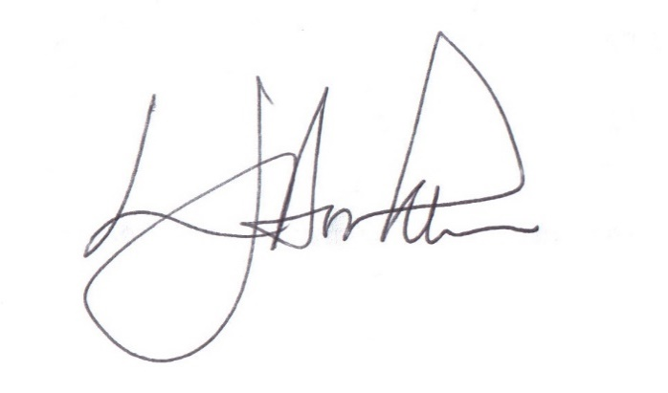**All completed** applications must be **received** by **SATURDAY, MARCH 14, 2020**. Your application can be completed electronically (with the exception of the letters of recommendation and the transcript). You may also download the entire application from our website, **www.diamondfoundationinc.org.** Complete and print the application and mail it to the aforementioned address. Please do not hesitate to contact me if there are any questions. Good luck.

Sincerely,

**Larnie J. Booker, M.D.**

*Scholarship Committee Chairman, The DIAMOND Foundation, Inc.*



**The DIAMOND Foundation, Inc.**

# Kappa Alpha Psi Fraternity, Inc., P.O. Box 1394, Somerset, New Jersey 08875-1394

### www.diamondfoundationinc.org

### Established in 2003

# 2020 Scholarship Application

**Eligibility requirements AND GENERAL INFORMATION**

* These scholarships are intended for graduating high school students who plan to attend a four-year institution of higher learning. Students must either have selected a college or completed the application process.
* All applicants must submit a current high school transcript. The minimum GPA necessary for scholarship consideration is 2.50.
* To be considered for a scholarship, all materials must be **RECEIVED** by **SATURDAY, MARCH 14, 2020**
* Scholarship awards will be presented in the form of a certificate and check which will be made payable to the awardee in a manner that will not affect any college or university financial aid package. The check will be dispersed upon receipt of proof of registration at a college or university.
* Recognition of our scholarship winners will occur at the Dr. George A. Patterson Scholarship Luncheon on Saturday, April 18, 2020 at The Marigold in Somerset, NJ. The winners will be notified three weeks in advance.

**Please submit the following with the completed application:**

* Personal Data Page (may include a resume as well)
* Two letters of recommendation
  + *One must be from a teacher or guidance counselor*
  + *All letters must be typed*
* An official copy of your high school transcript
* A photograph
* A 500 - 750 word essay answering the following questions:

**“What do you believe has been your greatest accomplishment and why?”**

**“ What did you need to overcome to be successful?”**

**All materials must be mailed directly to:**

**The DIAMOND Foundation, Inc.**

**ATTN: Scholarship Committee**

**93 S. Dover Avenue**

**Somerset, NJ 08873**

### Application Deadline: SATURDAY, MARCH 14, 2020



**The DIAMOND Foundation, Inc.**

# Kappa Alpha Psi Fraternity, Inc., P.O. Box 1394, Somerset, New Jersey 08875-1394

### www.diamondfoundationinc.org

### Established in 2003

# PERSONAL DATA SHEET

***Please type or print clearly***

**Name: Date of Birth: Age:**

**Mailing Address:**

**City ______________________________ State _____________ Zip Code ________________**

**Phone Number:**

**E-mail address:**

**Parent(s) Name(s) or Guardian(s) Name(s)/Occupation(s)**

**High School: Grade Point Average:**

**School Activities:**

**Community Activities**

**Employment Experience:**

**Awards, Recognitions and Notable Achievements:**

**Colleges Applied to:**

**College Acceptances:**

**Intended Major or Course of Study:**

**College Chosen:**

**Career Goal(s):**

**Hobbies:**

**Who are your role models and why:**

**How did you find out about our scholarship?**

* Teacher/ Guidance Counselor
* Kappa League
* Rutgers Upward Bound
* Civic League
* Church Bulletin – Church _______________________________________________
* Brother of Kappa Alpha Psi Fraternity, Inc.
* Other _____________________________________________

**I AGREE THAT ALL AFOREMENTIONED INFORMATION SUBMITTED ON THIS APPLICATION TO THE DIAMOND FOUNDATION, INC. OF THE NEW BRUNSWICK ALUMNI CHAPTER OF KAPPA ALPHA PSI FRATERNITY, INC. IS CORRECT AND TRUTHFUL TO THE BEST OF MY KNOWLEDGE. I AM ALSO AWARE THAT IF ANY OF THIS INFORMATION IS FOUND TO BE INCORRECT OR UNTRUTHFUL, MY APPLICATION WILL BE WITHDRAWN FROM CONSIDERATION AND I WILL NOT BE ELIGIBLE TO RECEIVE A SCHOLARSHIP. BY SIGNNG THIS APPLICATION, THE APPLICANT RELEASES THE USE OF HIS/HER NAME AND PICTURES FOR ADVERTISING PURPOSES IF HE/SHE IS SELECTED AS AN AWARD RECIPIENT.**

APPLICANT’S SIGNATURE: DATE:



**The DIAMOND Foundation, Inc.**

# Kappa Alpha Psi Fraternity, Inc., P.O. Box 1394, Somerset, New Jersey 08875-1394

### www.diamondfoundationinc.org

### Established in 2003

# TRANSCRIPT REQUEST

is applying for a scholarship sponsored by **The DIAMOND Foundation, Inc. of the New Brunswick Alumni Chapter of Kappa Alpha Psi Fraternity, Inc.** A transcript is required to evaluate the academic standing of the applicant. Kindly mail an official copy of the transcript to:

**The DIAMOND Foundation, Inc.**

**ATTN: Scholarship Committee**

**93 S. Dover Avenue**

**Somerset, NJ 08873**

**Application Deadline: SATURDAY, MARCH 14, 2020**

Parent’s signature Counselor’s signature

Date Date